Parents/Carers of Year 11 Students Our Ref: SKN/lha

12th February 2021

Dear Parent/Carer
Year 11 Assessments
You will know by now that your child has a period of assessment after February half term. In my previous letter to you I explained the purpose of these assessments:
What is the purpose of the assessments after Half Term?
The two weeks after Half Term have always been planned as a set of Pre-Public Exams. (PPEs) However, we will continue to use this time to complete key assessments in each subject. Students will…
- Complete an assessment in each subject, during the first two weeks of Term 4. This provides an opportunity for students to show what they can do, know and understand.
- The assessments have been designed carefully and are based on the curriculum in each subject. Some assessments will feel like an exam paper that you have seen before, some will be part questions. Teachers will inform students of the content and structure of the assessment before the end of term.
- Complete the assessment remotely, at set times across the two weeks. An assessment timetable will be published shortly.
- Submit the assessment by the time set.
- Receive feedback and a mark for each assessment. The assessments are not graded. Grading through teacher assessment will only happen at the end of the course.
- The feedback that students receive will be used so that students can improve their work.
The assessments are only one part of the evidence that teachers will use and the feedback from the assessments and will allow students to improve the quality of the work in the rest of Term 4.
This letter aims to clarify details around timings of these assessments, how they will be administered and provide subject specific details to support you and your child to prepare as well as possible for these assessments. There is also information about what additional support is available if you are concerned about your child’s mental health and wellbeing.

The following is the assessment timetable for the first two weeks of Term 4:
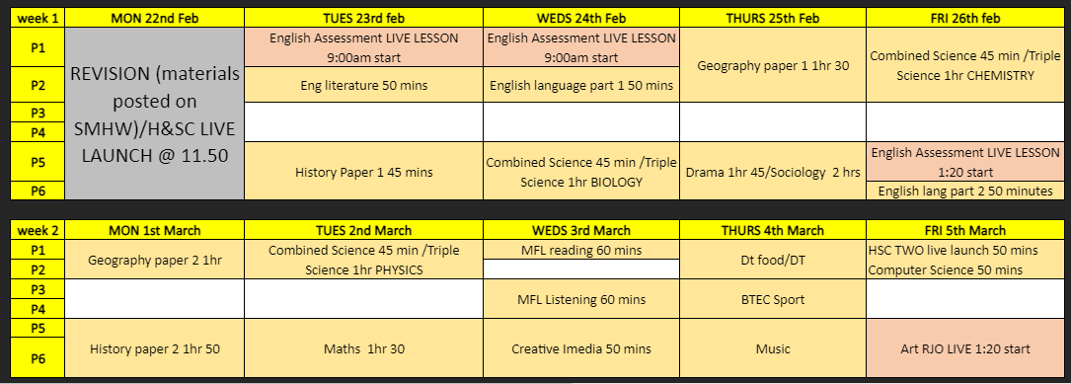

If you have any further concerns or questions please do contact Mrs Tushingham or Mrs Harris. (Rebecca.tushingham@clf.uk, Louisa.Harris@clf.uk)
Please also visit the Year 11 blog on the Academy Website where the following resources are available:
- Revision top tips
- English assessment Q&A
- Narrated guide to using Microsoft forms
- Access arrangements further reading
Yours sincerely

Mrs R Tushingham
Associate Assistant Principal
Raising Attainment Lead

